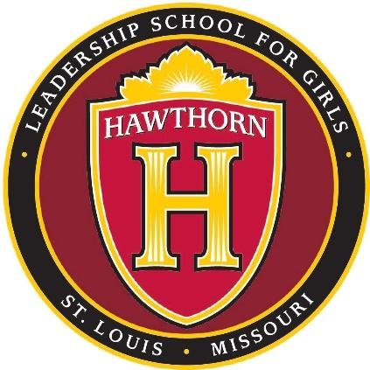
Hawthorn Leadership School for Girl
Operations: 3910
Title: Wellness Education

Hawthorn Leadership School for Girls (HLSG) is committed to contributing to the good health and total wellness of its students by implementing food service and physical/health education programs which promote positive dietary and lifestyle practices. The programs are an integrated part of the total learning environment and curriculum, and are designed to maximize student well-being and academic achievement. All staff members are encouraged to take advantage of opportunities to incorporate sound nutrition concepts and physical fitness activities into their curriculum.
Involvement in policy development and modification
HLSG will periodically involve parents, students, food service personnel, school administrators and Board members in decisions regarding the development, implementation, evaluation and modification of the wellness policy and practices.
Goals for nutrition education, physical activity and other student wellness activities
Goals of HLSG’s wellness program are to:
- Help students acquire knowledge and awareness and develop behavior which contributes positively to lifelong wellness.
- Offer a required physical education curriculum and a co-curricular program which results in frequent exercise and enjoyment, develops a lifelong appreciation for sports, and promotes a lifelong commitment to wellness practices.
- Enhance academic achievement through better health and school attendance.
- Integrate wellness and physical activities as ongoing components of the total curriculum.
- Follow practices and teach curriculum which promotes and shows the way to good student health, including the avoidance and/or reduction of obesity.

Nutrition guidelines
HLSG’s nutrition guidelines and practices which govern the food service operation apply to all foods and beverages available on school campuses during the school day, and will comply with the nutrition standards established by the U. S. Department of Agriculture (USDA). These standards apply specifically to:
- National School Lunch Program and School Breakfast Program Meals
- A la carte offerings in the food service program
- Vending machines and school stores
- Classroom parties, celebrations, fundraisers, rewards and school events
- Snacks served in pre-school and after-school programs.

Physical education and activities
The curriculum and objectives for nutrition and physical/health education, life sciences, and family and consumer sciences are aligned with the Show-Me Standards and Missouri’s Frameworks for Curriculum Development in Health/Physical Education.
Monitoring and evaluation
HLSG’s staff in conjunction with the school’s food service provider are responsible for:
- Involving the parties indicated above in the wellness curriculum development process;
- Implementing and monitoring the wellness plan.
- Evaluating success of the plan.
- Effecting changes to the plan as required.
- Reporting results periodically to the Board of Directors.

Assurances
HLSG’s guidelines for reimbursable school meals will be no less restrictive than regulations and guidance issued by the Secretary of Agriculture pursuant to the Child Nutrition Act and National School Lunch Act. HLSG’s food service and physical/health education programs are also designed to meet other state and federal requirements.
Approved:
Background Legal Reference: 167.720, 610.010 - .030, RSMo.
The Child Nutrition and WIC Reauthorization Act of 2004, Section 204, P.L. 108 - 265
The Richard B. Russell National School Lunch Act, 42 U.S.C. §§ 1751 – 176

